VERSION CONTROL LAB

1. The local repository should have a file called git_ex.txt

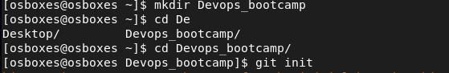

1. The file git_ex_txt should be updated with the following lines of text #! /bin/bash
2. Save the changes and add the file_ex.txt to the staging area
3. Finalize it by committing it to local repository

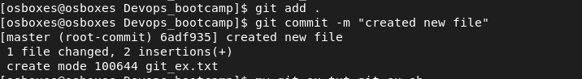

1. You realise the file git_ex.txt is meant to be a bash script, change the file name to make the file a bash script

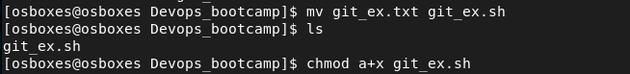

1. Find a way to save the changes and update the local repository with the new state

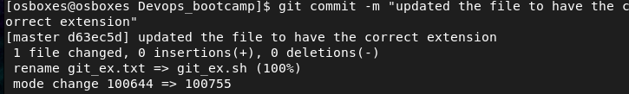

1. Run the git log to see the various commits you have made

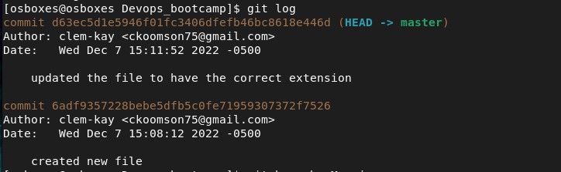

1. Create a remote repository in GitHub and push your code



